LAB 7 TASK

TASK 01:

Write a program in C to separate odd and even integers into separate arrays.

**Source code**

**#include<stdio.h>**

**int main()**

**{**

**int odd[10],even[10],arr[10];**

**int i,j;**

**printf("ENTER 10 integers:\n");**

**for(i=0;i<10;i++)**

**{**

**scanf("%d",&arr[i]);**

**}**

**printf("EVEN NUMBERS FROM ARRAY ARE:\n");**

**for(i=0;i<10;i++)**

**{**

**if(arr[i]%2==0)**

**{**

**even[i]=arr[i];**

**printf("%d\n",even[i]);**

**}**

**}**

**printf("ODD NUMBERS FROM ARRAY ARE:\n");**

**for(i=0;i<10;i++)**

**{**

**if(arr[i]%2!=0)**

**{**

**odd[i]=arr[i];**

**printf("%d\n",odd[i]);**

**}**

**}**

**}**

**OUTPUT**

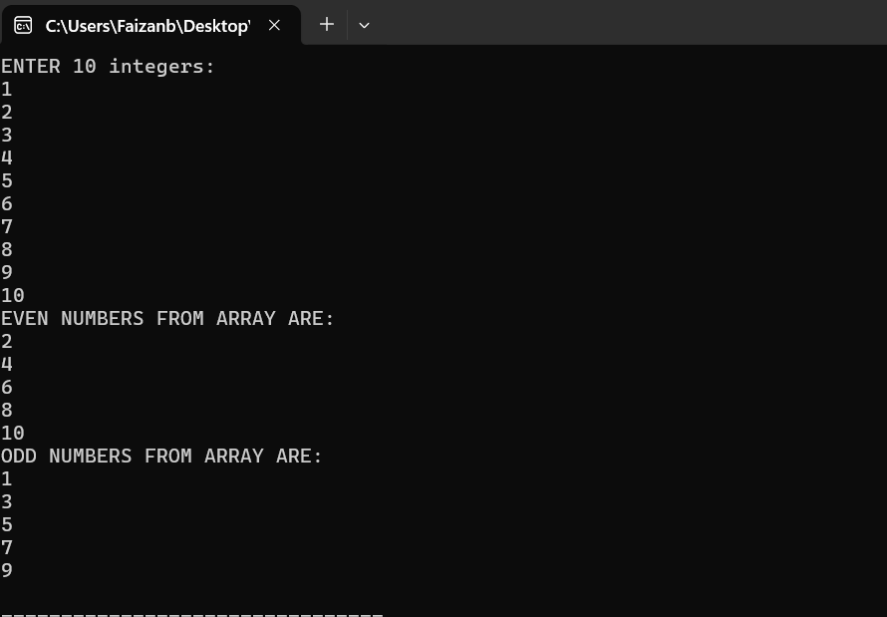

TASK 02:

Write a program in C to find the second largest element in an array.

**SOURCE CODE:**

**#include<stdio.h>**

**int main()**

**{**

**int arr[5];**

**int i,first_max,sec_max;**

**printf("ENTER 5 NUMBERS:\n");**

**for(i=0;i<5;i++)**

**scanf("%d",&arr[i]);**

**first_max=sec_max=-21347;**

**for(i=0;i<5;i++)**

**{**

**if(arr[i]>first_max)**

**first_max=arr[i];**

**}**

**for(i=0;i<5;i++)**

**{**

**if(arr[i]>sec_max && arr[i]<first_max)**

**sec_max=arr[i];**

**}**

**printf("SECOND LARGEST ELEMENT IS %d",sec_max);**

**}**

**OUTPUT**

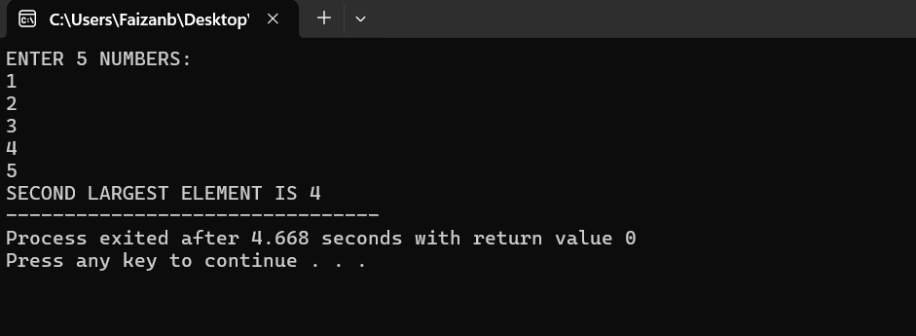

TASK 03:

Write a C program that prompts the user to input 10 integers but checks to ensure all inputs are positive numbers. If a negative number is entered, prompt the user to re-enter until valid input is received.

For example:

Enter 10 positive integers:

Enter integer 1: 2

Enter integer 2: 3

Enter integer 3: -7

Invalid input! Please enter a positive integer.

Enter integer 3: 6

Enter integer 4: 5

Enter integer 5: 5

Enter integer 6: 4

Enter integer 7: 6

Enter integer 8: 3

Enter integer 9: 2

Enter integer 10: 1

You entered the following positive integers:

2 3 6 5 5 4 6 3 2 1

**SOURCE CODE**

**#include<stdio.h>**

**int main()**

**{**

**int arr[10],i;**

**printf("ENTER 10 NUMBERS:\n");**

**for(i=0;i<10;i++)**

**{**

**scanf("%d",&arr[i]);**

**if(arr[i]<0)**

**{**

**printf("Invalid input! Please enter a positive integer\n");**

**i = i -1;**

**}**

**}**

**printf("POSTIVE NUMBERS:\n");**

**for(i=0;i<10;i++)**

**{**

**printf("%d\n",arr[i]);**

**}**

**}**

**OUTPUT:**

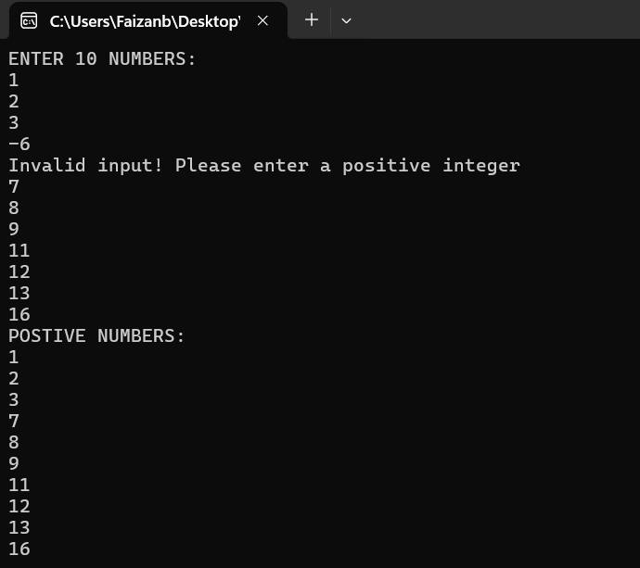

TASK 04:

Write a C program to rotate the elements of an array to the right by one position. For example, {1, 2, 3, 4, 5} becomes {5, 1, 2, 3, 4}.

SOURCE CODE

#include<stdio.h>

int main()

{

int i,t,n,x;

printf("ENTER THE NUMBER OF ELEMENTS IN ARRAY:");

scanf("%d",&n);

int arr[n];

printf("ENTER %d ELEMENTS OF ARRAY:\n",n);

for(i=0;i<n;i++)

{

scanf("%d",&arr[i]);

}

t = arr[n-1];

for(i=n-1;i>0;i--)

{

arr[i] = arr[i-1];

}

arr[0] = t;

printf("ROTATED ARRAY IS:\n");

for(i=0;i<n;i++)

{

printf("%d\n",arr[i]);

}

}

OUTPUT

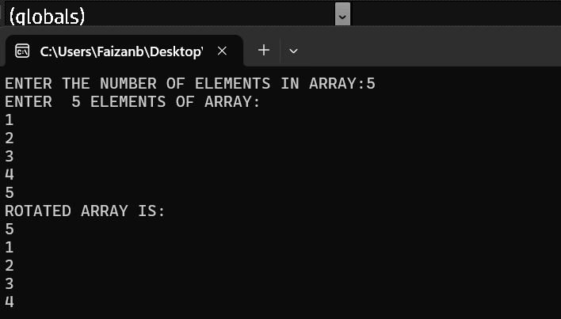

TASK 05:

Write a C program that removes all zeros from an integer array and shifts the remaining elements to the front. The output should not contain any zeros. For example: Enter the number of elements in the array: 10

Enter 10 integers:

Element 1: 4

Element 2: 5

Element 3: 0

Element 4: 3

Element 5: 7

Element 6: 0

Element 7: 5

Element 8: 0 Element 9: 0

Element 10: 8

OUTPUT: Array after removing zeros: 4 5 3 7 5 8

SOURCE CODE:

#include<stdio.h>

int main()

{

int n;

int i;

printf("ENTER THE NUMBER OF ELEMENTS IN ARRAY:\n");

scanf("%d",&n);

int arr[n];

printf("ENTER THE ELEMENTS OF ARRAY:\n");

for(i=0;i<n;i++)

{

scanf("%d",&arr[i]);

}

for(i=0;i<n;i++)

{

if(arr[i]==0)

continue;

printf("%d ",arr[i]);

}

}

OUTPUT:

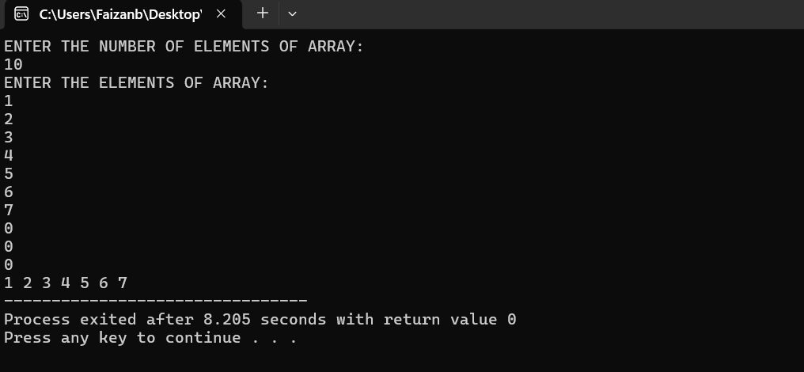

TASK 06:

Write a C program that counts the number of digits and special characters in a string.

SOURCE CODE:

#include<stdio.h>

int main()

{

char str[10];

int digit =0,s_char=0;

int i;

printf("ENTER A STRING:\n");

scanf("%[^\n]",str);

for(i=0;str[i]!='\0';i++)

{

if(str[i]>=48 && str[i]<=57)

digit++;

else if((str[i]<47 || str[i]>57)&&(str[i]<65 ||str[i]>90)&&(str[i]<97 || str[i]>122))

s_char++;

}

printf("TOTAL DIGITS IN STRING ARE %d\n",digit);

printf("TOTAL SPECIAL CHARACTERS IN STRING ARE %d\n",s_char);

}

OUTPUT:

